实验八：适配器模式

(1) 类适配器

1.1 UML图

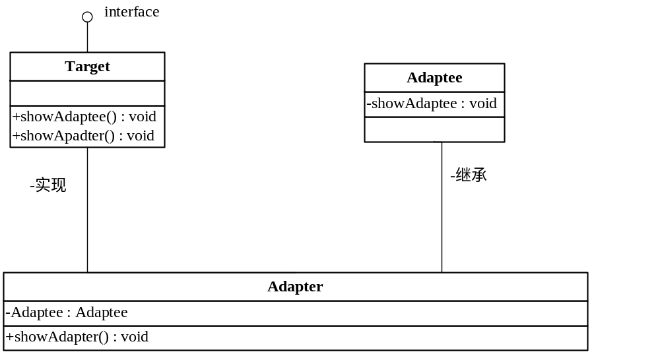

1.2 代码
package cn.edu.scau.cmi.liuweiming.adapter;

public class Adaptee {
public void showAdaptee() {
System.out.println("Adaptee");
}
}

package cn.edu.scau.cmi.liuweiming.adapter;

public class AdapterOfClass extends Adaptee implements Target {

public void showAdapter() {
// TODO Auto-generated method stub
System.out.println("Adapter");
}

}

package cn.edu.scau.cmi.liuweiming.adapter;

public interface Target {
void showAdapter();
void showAdaptee();
}

Client:
package cn.edu.scau.cmi.liuweiming.client;

import cn.edu.scau.cmi.liuweiming.adapter.AdapterOfClass;
import cn.edu.scau.cmi.liuweiming.adapter.AdapterOfObject;
import cn.edu.scau.cmi.liuweiming.adapter.Target;
import cn.edu.scau.cmi.liuweiming.adapter.TargetOfObject;

public class AdapterClient {
public static void main(String[] args) {
Target A = new AdapterOfClass();
A.showAdaptee();
A.showAdapter();

TargetOfObject B = new AdapterOfObject();
B.showAdapter();
B.showAdaptee();

}
}

1.3 实现效果
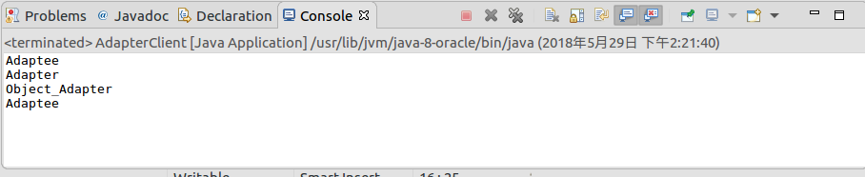

(2) 对象适配器

2.1 UML图

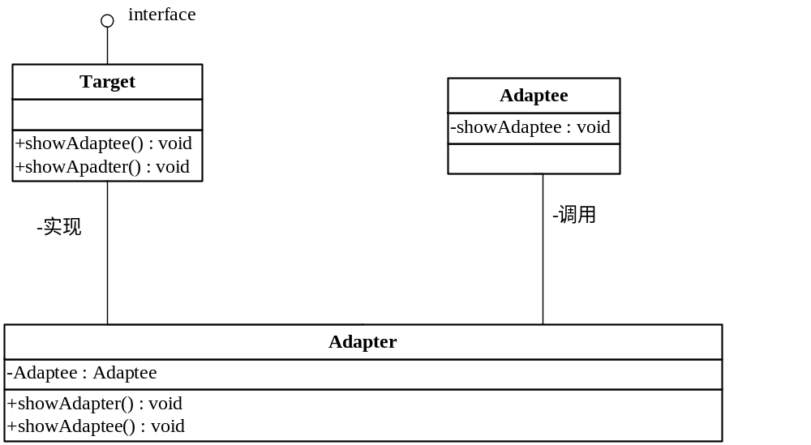

2.2 代码
package cn.edu.scau.cmi.liuweiming.adapter;

public class Adaptee {
public void showAdaptee() {
System.out.println("Adaptee");
}
}

package cn.edu.scau.cmi.liuweiming.adapter;

public class AdapterOfObject implements TargetOfObject {

Adaptee res = new Adaptee();

public void showAdapter() {
// TODO Auto-generated method stub
System.out.println("Object_Adapter");
}

public void showAdaptee() {
// TODO Auto-generated method stub
res.showAdaptee();
}

}

package cn.edu.scau.cmi.liuweiming.adapter;

public interface TargetOfObject {
void showAdapter();
void showAdaptee();
}

Client:
package cn.edu.scau.cmi.liuweiming.client;

import cn.edu.scau.cmi.liuweiming.adapter.AdapterOfClass;
import cn.edu.scau.cmi.liuweiming.adapter.AdapterOfObject;
import cn.edu.scau.cmi.liuweiming.adapter.Target;
import cn.edu.scau.cmi.liuweiming.adapter.TargetOfObject;

public class AdapterClient {
public static void main(String[] args) {
Target A = new AdapterOfClass();
A.showAdaptee();
A.showAdapter();

TargetOfObject B = new AdapterOfObject();
B.showAdapter();
B.showAdaptee();

}
}

2.3 实验效果

